 |  |  | 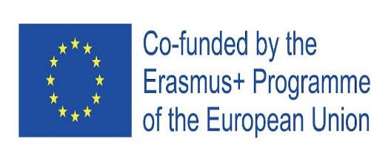

Groundwater detection system : Technical report and User guide

Firstname : Tsantamirindra
Lastname : RANDRIANARISOA
Course : System Design and Simulation
Erasmus Student from Madagascar 2025-2026
Table of contents
Introduction 1
1. System overview 2
1.1. Module 1 : Data generation and visualization 2
1.2. Module 2 : Groundwater detection and analysis 2
1.3. Workflow of the system 3
2. Methodology and Implementation 4
2.1. Resistivity information and classification 4
2.2. Module 1 : Data generation and visualization 4
2.3. Module 2 : Groundwater detection and analysis 5
3. User guide 6
3.1. Requirements 6
3.2. Project setup 7
3.3. Execution steps 7
Conclusion 9
Introduction
Groundwater is a critical natural resource that requires careful monitoring and sustainable management. Overexploitation or poor management can lead to aquifer depletion, droughts, and long-term environmental damage. Efficient detection and analysis of groundwater resources are therefore essential to preserve water availability, optimize usage for agricultural and community needs, and prevent water scarcity.
This project addresses this challenge by proposing a groundwater detection and analysis system based on data visualization and computer vision techniques using machine learning and artificial intelligence methods. By interpreting groundwater-related plots, the system aims to identify and rank the most probable locations for groundwater presence, from the most to the least favorable areas.
This report is organized as follows: first, an overview of the system and its general workflow is presented. Then, the implementation is detailed, including the purpose and motivation of each module, the technologies and libraries used, and the methodology adopted, with a logical explanation of the approach, the main steps of the code, and the types of inputs and outputs. Finally, a user guide explains how to run the project and reproduce the results using the provided GitHub repository.

- System overview
The groundwater detection system is composed of two main modules that work together to generate, visualize, and analyze groundwater data. Its goal is to identify the most probable locations for groundwater presence and rank them according to their potential.
  - Module 1 : Data generation and visualization
In real-world scenarios, groundwater data are usually collected by specialized devices. The input data are typically plots representing subsurface property named resistivity. Since we currently do not have access to actual data, this module generates synthetic data as an example for demonstration purposes.
The module performs the following tasks:
- Generates coordinate data (x, y, z) and resistivity values in CSV format.
- Plots these data to create images representing the subsurface layers.
These synthetic plots serve as input for the subsequent analysis module, providing a visual representation of potential groundwater areas.
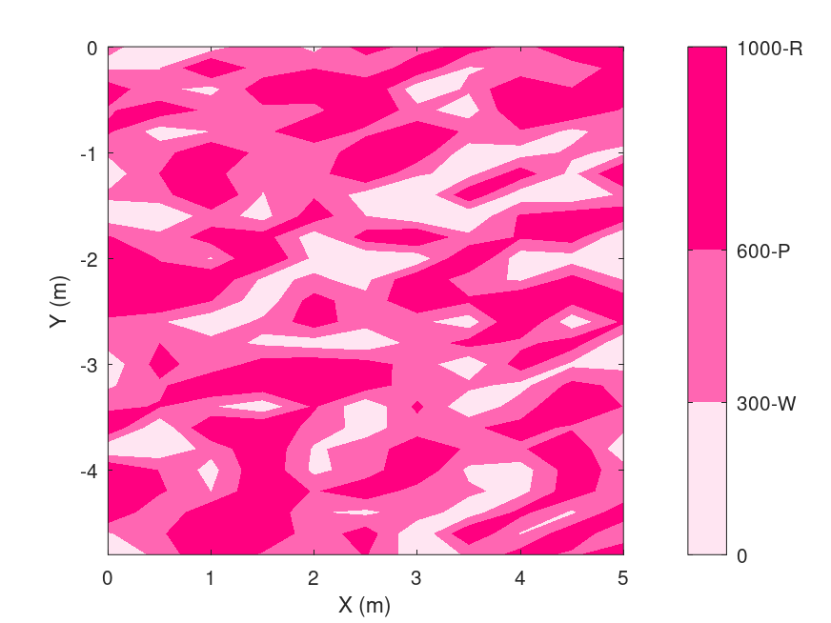 | 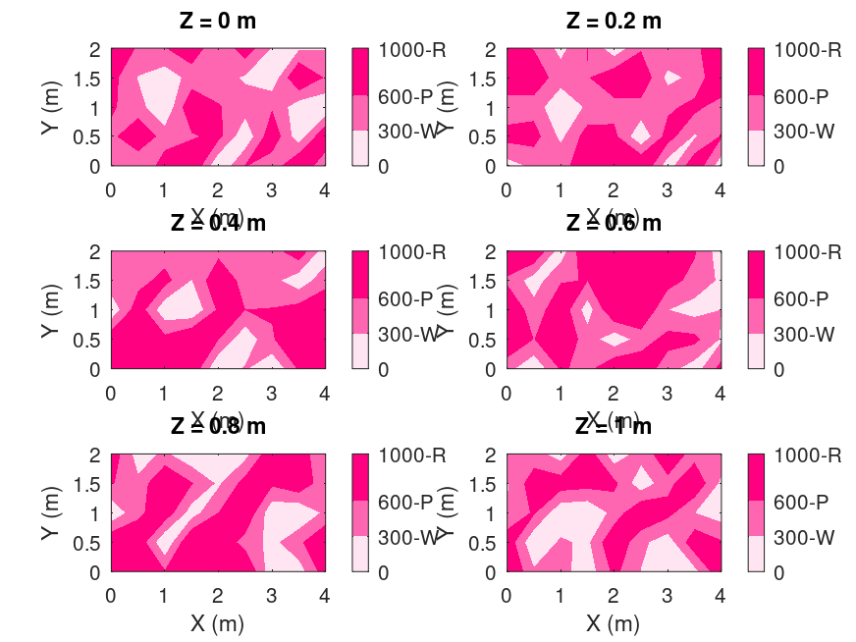
Examples of output from module 1
  - Module 2 : Groundwater detection and analysis
This module takes the plots generated by the first module as input and applies computer vision techniques powered by machine learning to detect areas with high probability of groundwater presence.
The module then calculates the surface areas of these detected zones and ranks them, from the largest to the smallest, providing users with a prioritized list of potential groundwater locations.
The output is an image highlighting the detected zones along with their ranking by surface area, allowing users to quickly interpret and utilize the results.
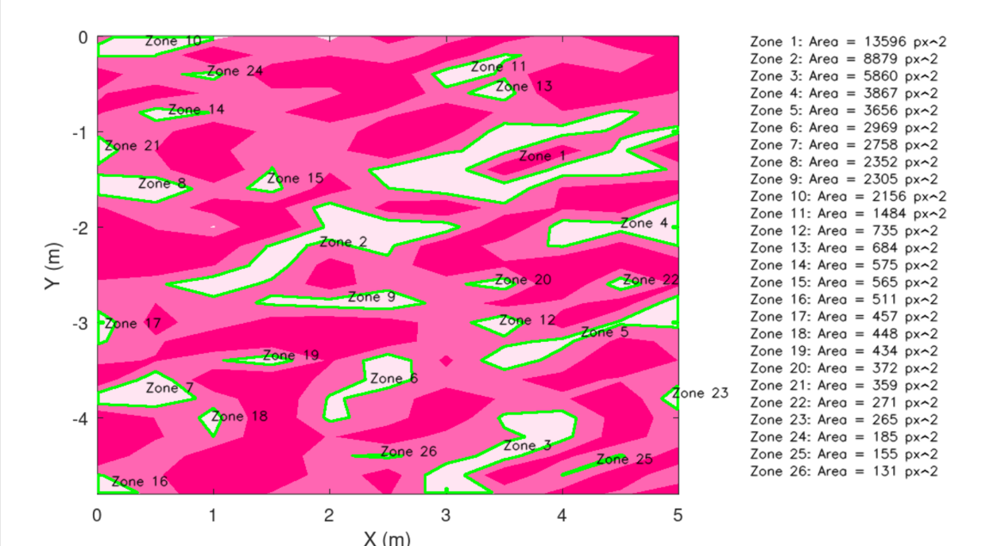
Example of output from module 2
  - Workflow of the system
The system workflow consists of three main stages. First, synthetic resistivity data are generated to simulate subsurface conditions and saved as CSV files. Second, these data are visualized as 2D or 3D color-coded plots representing different resistivity classes. Finally, the generated plots are analyzed using a Python-based computer vision model that detects, quantifies, and ranks potential groundwater zones based on their resistivity and surface area. The output includes annotated maps highlighting the detected zones and corresponding numerical information, providing a comprehensive guide for groundwater exploration.
- Methodology and Implementation
  - Resistivity information and classification
In this project, electrical resistivity is considered as the main subsurface parameter for groundwater analysis. Resistivity is widely used in geophysical studies as it provides valuable information about underground materials and fluid content, making it a relevant indicator for groundwater presence.
The resistivity values are classified into three distinct categories, each representing a different type of subsurface environment:
- Water-dominated environments: resistivity values ranging from 0 to 300 ohms, indicating a high probability of groundwater presence.
- Transition or mixed zones: resistivity values between 300 and 600 ohms, corresponding to areas with mixed geological properties.
- Dry rock or hydrocarbon-dominated zones: resistivity values from 600 to 1000 ohms, representing zones with low groundwater potential.
Based on this classification, the synthetic data generated in this project are limited to a resistivity range of 0 to 1000 ohms. For visualization purposes, each resistivity class is represented using a distinct color scale, ranging from light pink (water-dominated zones) to dark pink (dry or hydrocarbon-dominated zones). This visual encoding enhances the interpretability of the generated plots and facilitates subsequent computer vision–based groundwater detection.
  - Module 1 : Data generation and visualization
Synthetic data generation allows controlled experimentation and validation of the proposed detection approach. By simulating resistivity values within predefined ranges (as described in Section 1.1), the system can be tested under consistent conditions while reflecting realistic geophysical assumptions. Converting numerical resistivity values into visual plots also facilitates interpretation by both humans and computer vision algorithms.
    - Technologies and libraries used
Programming language | GNU Octave
Core functions | CSV file handling, numerical interpolation, plotting utilities
Visualisation tools | contourf for creating filled contour maps

    - Methodology
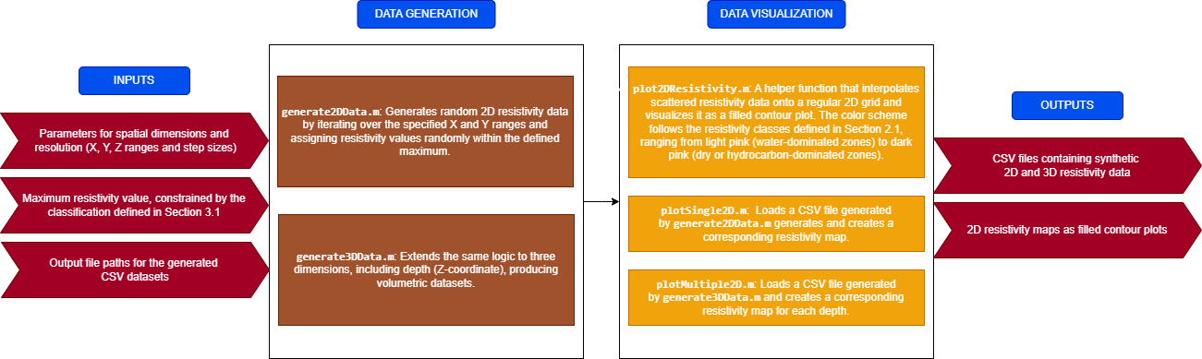
  - Module 2 : Groundwater detection and analysis
Resistivity maps provide a natural visual representation of subsurface conditions. Computer vision techniques are well suited to interpret these plots and extract quantitative information about potential groundwater zones. Detecting connected low-resistivity areas and ranking them by size enables users to focus on the most significant zones for practical exploration or further investigation.
    - Technologies and libraries used
Programming language | Python 3.x
Execution environment | Jupyter Notebook
Libraries | - opencv-python (image processing and contour detection)  - numpy (numerical computation)

    - Methodology

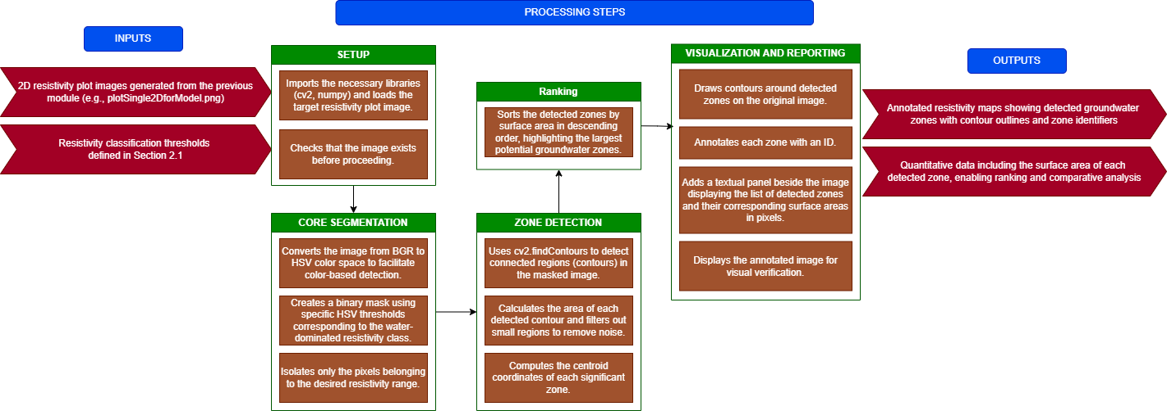

- User guide
This section explains how to set up the required environment and how to execute the different modules of the groundwater detection system.
  - Requirements
To run the project successfully, the following tools and environments are required.
General | - Operating System : Windows, Linux, or macOS  - Git (to clone the repository)
Module 1 – Data generation and visualtization | GNU Octave or MATLAB ( GNU Octave open-source is recommended)
Module 2 – Groundwater detection and analysis | - Python 3.x  - Jupyter Notebook  - Python libraries : pip install opencv-python numpy
  - Project setup
- Clone the GitHub repository :
git clone https://github.com/Tsanta04/Simulation.git

- Navigate to the project directory :
cd Simulation

- Verify the project structure :
Simulation/
├── Code/ # Octave scripts for data generation and plotting
├── Data/ # Generated CSV data
├── Documentation/ # Documentation of this project
├── Plot/ # Generated plot images
└── Model/ # Python notebook for groundwater detection

For better organization and usability of the project, it is recommended to follow the proposed directory structure. The Code folder should be used exclusively for Octave scripts related to data generation and visualization. The Data directory helps centralize all generated CSV files, making it easier to manage and reuse datasets. The Plot folder allows users to store and compare generated resistivity maps in a consistent manner. Finally, the Model directory groups all Python-based analysis tools, ensuring a clear separation between data generation and groundwater detection. Adhering to this structure improves readability, maintainability, and overall understanding of the workflow.
  - Execution steps
- Generate synthetic resistivity data
Open GNU Octave and run this code :
cd Code
generate2DData('../Data/nappes2D.csv', 5, 0.5, 0.2, 1000);
generate3DData('../Data/nappes3D.csv', 4, 2, 1, 0.5, 0.5, 0.2, 1000);

- Visualize resistivity data
Plot the generated data as a resistivity map :
plotSingle2D('../Data/nappes2D.csv');

- Groundwater detection and analysis
- Navigate to the Model directory and launch Jupyter Notebook :
cd Model
jupyter notebook

- Select Untitled.ipynb to be opened to the notebook :
Untitled.ipynb

- When you open the Jupyter Notebook, you will see the code. Make sure that the input image path is correct and corresponds to the image generated in Step 2.
image = cv2.imread('../Plot/plotSingle2DforModel.png')

- Run all cells in the notebook
Conclusion
This project presented a complete groundwater detection system combining synthetic data generation, scientific visualization, and computer vision-based analysis. By using electrical resistivity as the primary subsurface parameter, the system demonstrates how geophysical concepts can be translated into visual representations and subsequently interpreted using machine learning and image processing techniques.
The proposed approach is structured around two complementary modules. The first module generates and visualizes synthetic resistivity data, providing a controlled and reproducible environment in the absence of real-world measurements. The second module analyzes the resulting plots using computer vision methods to detect, quantify, and rank potential groundwater zones based on their surface area. This ranking offers a practical decision-support tool for identifying the most promising areas for further exploration.
The current implementation relies on simulated data and is intentionally designed as a prototype that can be extended to real-world applications. Future improvements include the integration of real resistivity measurements, greater flexibility in resistivity classification to support additional or site-specific categories, and the incorporation of geospatial mapping to guide users directly toward the most significant groundwater zones rather than relying solely on ranked results. Overall, the project establishes a solid foundation for transforming a prototype system into a practical groundwater exploration tool.

